ISSN 1392-1320 MATERIALS SCIENCE (MEDŽIAGOTYRA). Vol. XX, No. X. 2024

Camera-Ready Articles Preparation Instructions for “Materials Science (Medžiagotyra)” Journal (ISSN 1392-1320)

(Author’s) Name SURNAME ^{1 ∗}, Name SURNAME ², Name SURNAME ^{1, 2}

¹ Affiliation, postal address
² Affiliation, postal address
http://doi.org/10.XXXX/j01.xxxxxxx

Received XX June 201X; accepted XX December 201X
At this place, you should write an abstract. The abstract should not be longer than approximately 2000 characters.
At this place, you should write an abstract. The abstract should not be longer than approximately 2000 characters.
Keywords: without leaving space after the abstract write your keywords or/and keyphrases (3 – 5 words or/and phrases).

1. ARTICLE SIZE∗
In order to achieve rapid publication, the texts will be printed directly from the author's typescripts.
Some flexibility of presentation will be allowed but authors are urged to arrange the subject matter clearly under such headings as INTRODUCTION, EXPERIMENTAL DETAILS, RESULTS, DISCUSSION, CONCLUSIONS, REFERENCES, etc.
The length of a paper text is not limited Not less than 75 % – 80 % the last page should be filled.
2. LAYOUT
The manuscript should be typed with single spacing using Microsoft Word processor (preferably). Times New Roman font should be used. The text should be typed in two columns on A4 format sheets; spacing between columns should be 6 mm. Leave 20 mm margins at the top, 25 mm at the bottom, and 18 mm on the left and right sides. Please, don’t use numbering pages in your articles.
The title of an article should be printed in 14 pt (Bold), author's name – 12 pt (Bold), title of the institution – 10 pt (Italic), headings of the chapters (in caps) – 11 pt (Bold), the body text and abstract – 10 pt, indexes – 8 pt, text of the tables – 9 pt, formulae in the text (using Microsoft Equation 3,0 programme) – 10 pt, indexes – 6 pt, subindexes – 5 pt (all symbols – Italic, vectors – Bold, numbers – Normal). Italic characters should be used for symbols from the figures and graphs mentioned in the text.
A new paragraph must be indented in the first line by 0.6 cm.
The corresponding author and the contacts must be footnoted at the end of the first page.
References should be numbered consecutively (numerals in square brackets) through the text and collected together in a reference list at the end of the paper. Please place the references according to their order of appearance in the text. Use 10 points, regular for the reference list. The authors should be typed in Bold, name of the article – Normal, Journal – Italic.
3. FIGURES and TABLES
The figures and tables must be numbered, have a self-contained caption. Figure captions should be below the figures; table captions should be above the tables. Please avoid placing figures and tables before their first mention in the text.
The text of figure captions should be 9 points high, Times New Roman and Normal. For the words Fig. and Table use Bold. For example, Fig. 7., Table 5. The name of the Figure should be made with Hanging of 0.95 cm. Name of the Table should be made with After spacing of 3 pt.
All the figures, graphs and photographs should be numbered and referred in the main text. Abscissas and ordinates of all graphs should be labeled with symbols and units.
All figures, graphs and photographs can be in colors as well as in black and white (or gray shades).
Figures, and tables should be arranged in such a way that they would fit into one (84 mm width) or two columns (only in the start or end of the page).
One line spacing should separate the figures and tables from the text.
The example of the Table and Figure is given below.
Table 1. Statistical parameters of Ag colloidal solution
Boiling time, min | SPR position, nm | FWHM, nm | Absorbance, a.u.
20 | 406.77 ±0.25 | 96.55 ±0.67 | 0.09 ±0.0005
25 | 423.24 ±0.28 | 68.82 ±0.69 | 0.53 ±0.004
60 | 439.79 ±0.44 | 84.43 ±1.34 | 2.99 ±0.04
90 | 433.00 ±2.78 | 177.34 ±1.40 | 2.29 ±0.01
120 | 422.64 ±2.78 | 189.07 ±1.40 | 2.64 ±0.01

Table 2. Example of the Table arranged at the top or end of the page in one column
 | Composition | Weave type | Area density W, g/m² | Direction | FAST |  | KES-F
 |  |  |  |  | Linear equation | R² | Linear equation | R²
Tested fabrics | I | twill (2/2) | 211 – 398 | warp | y = 0.24x – 38.33 | 0.98 | y = 0.33x – 56.87 | 0.98
 |  |  |  | weft | y = 0.13x – 17.27 | 0.93 | y = 0.17x – 26.59 | 0.92
 |  |  |  | mean | y = 0.18x – 27.80 | 0.97 | y = 0.25x – 41.73 | 0.96
Fabrics | II | plain, twill (2/1) | 96 – 170 | warp | – | 0.23 | – | 0.33
 |  |  |  | weft | y = 0.07x – 4.04 | 0.77 | y = 0.06x – 4.33 | 0.80
 |  |  |  | mean | y = 0.06x – 1.52 | 0.57 | y = 0.06x – 2.47 | 0.71

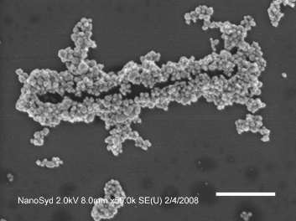 | 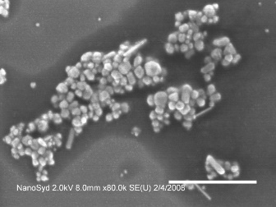 | 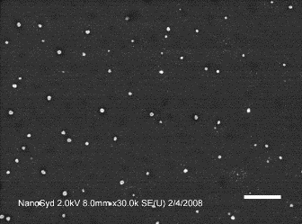 | 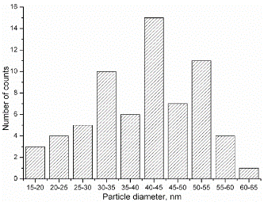
a | b | c | d
Fig. 1. Example of the Figure arranged at the top or bottom of the page in one column

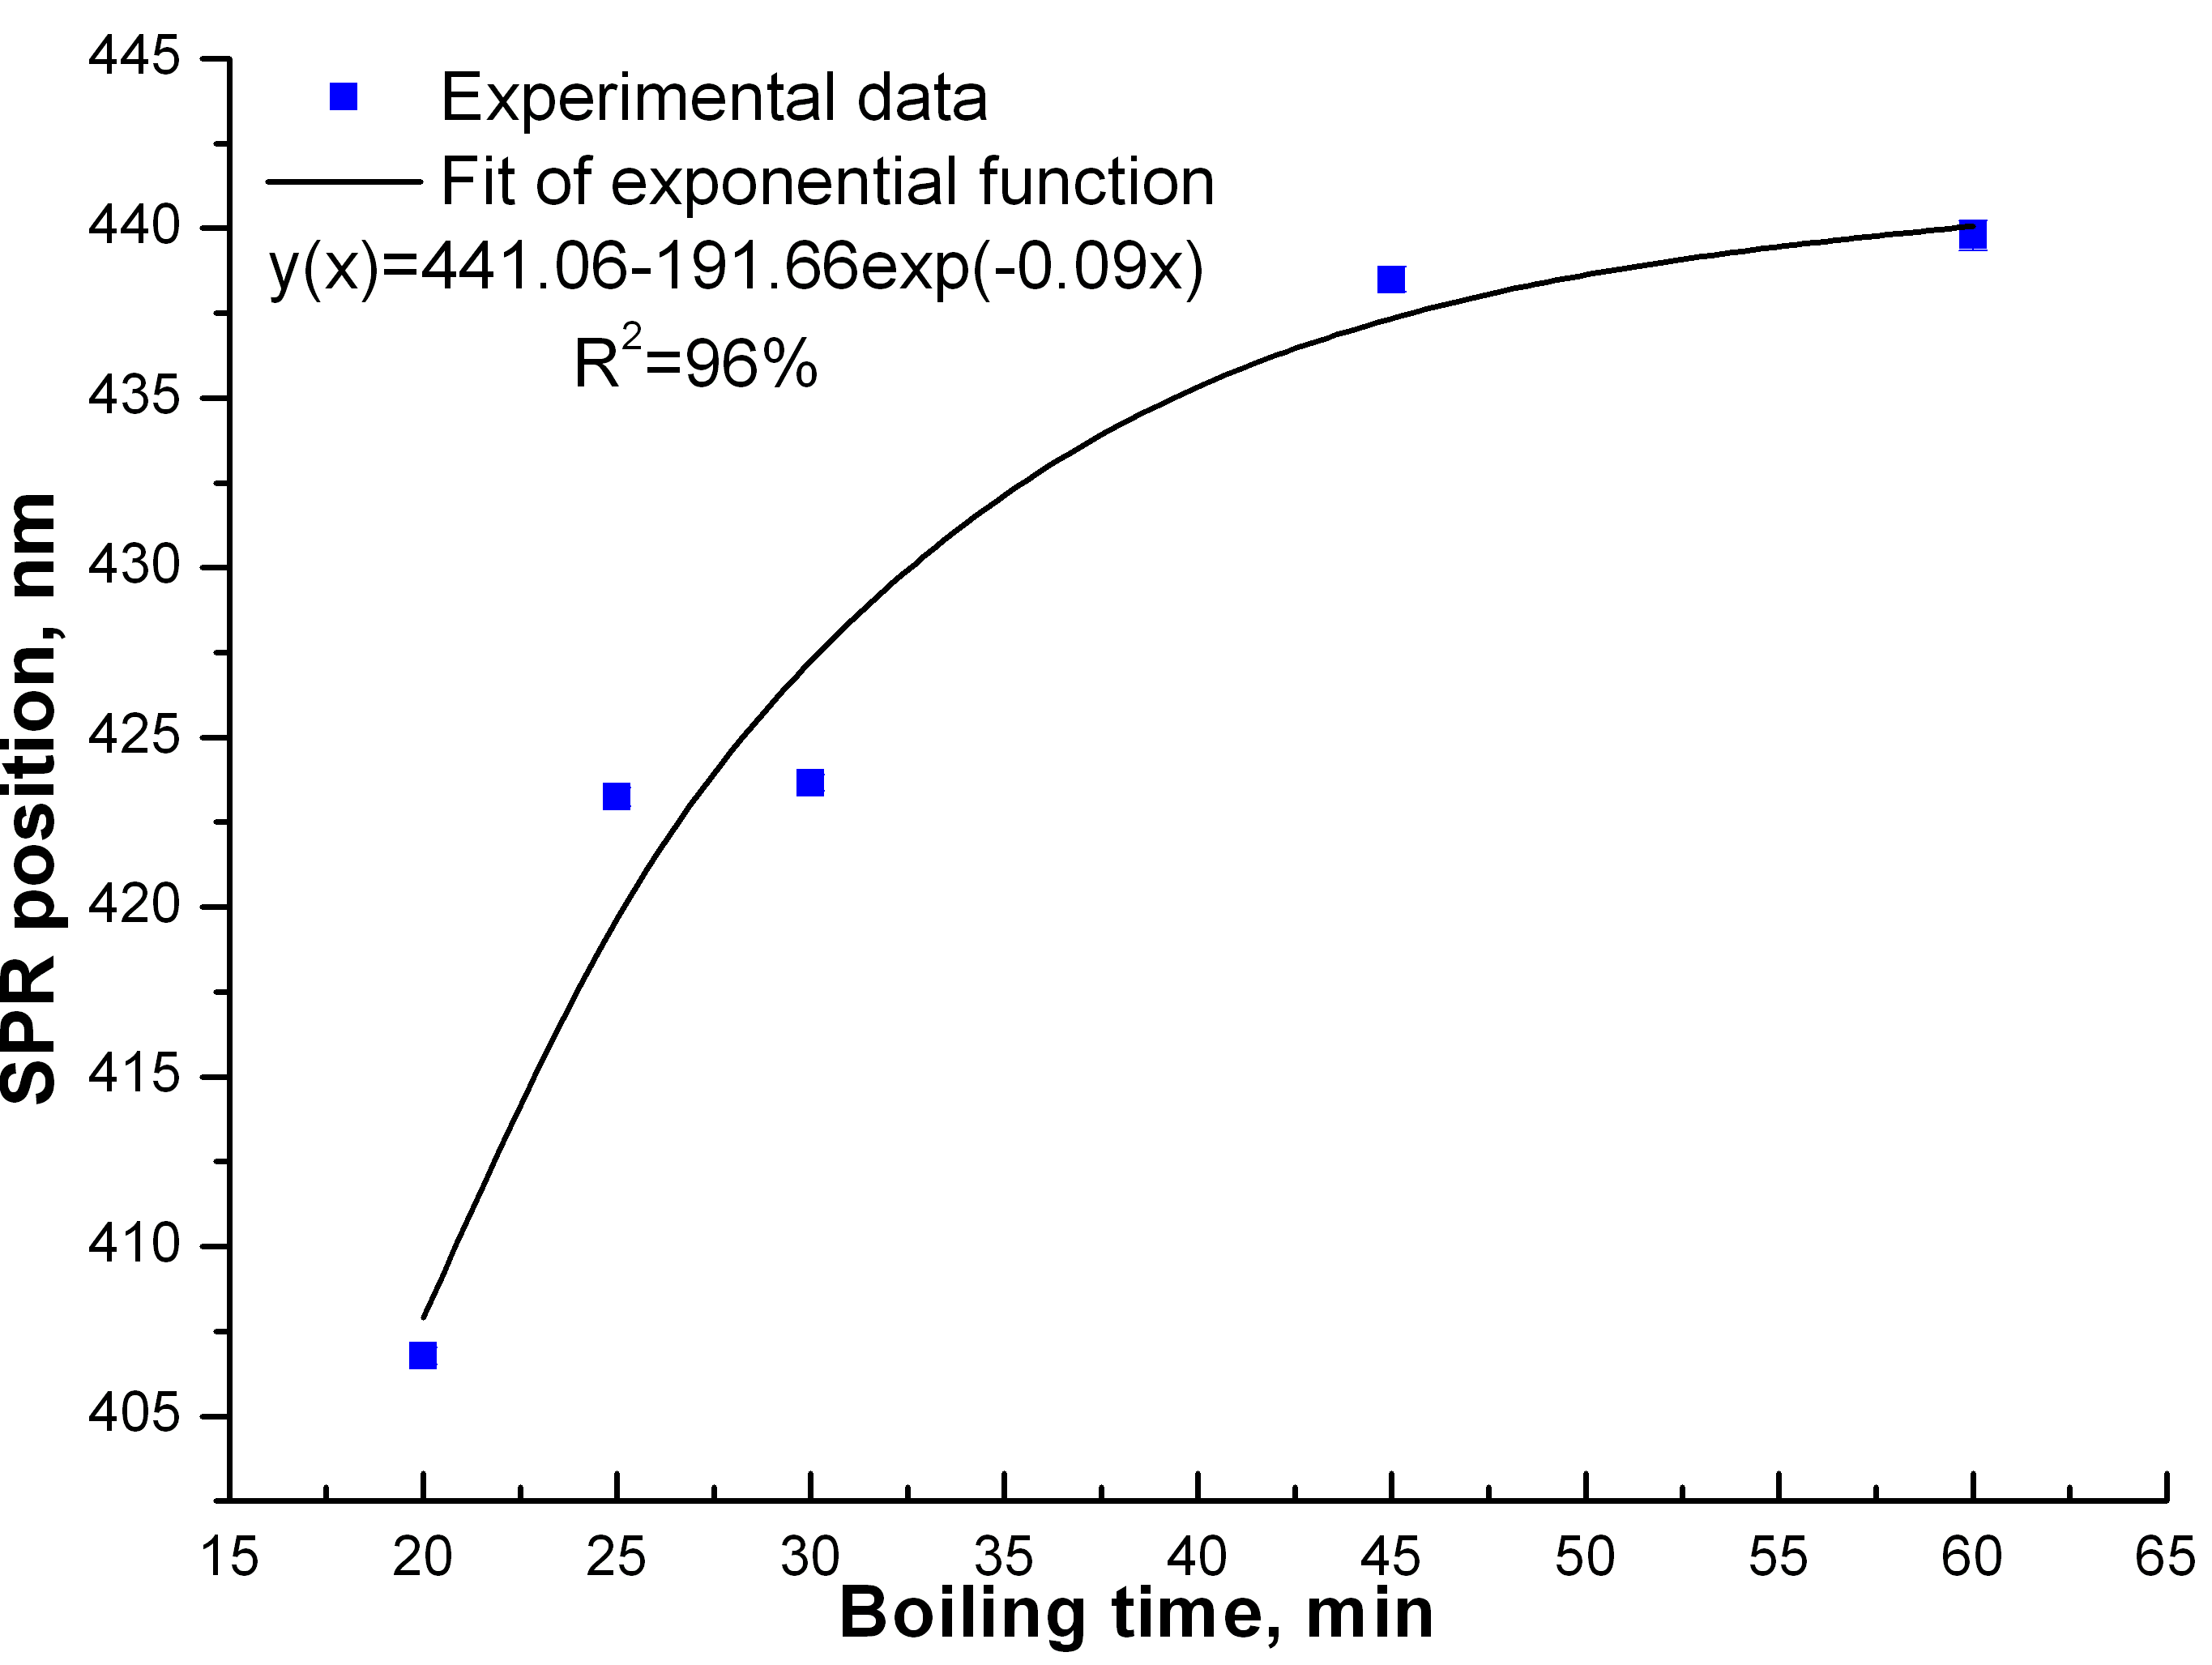
Fig. 2. SPR position dependence on boiling time (determined from the experimental data)
4. CONCLUSIONS
We thank you in advance for the usage carefully of instructions for camera-ready articles, which can be sent for publication with minor modification. The example of article published in Materials Science – Medžiagotyra is available at the Web Portal http:www.matsc.ktu.lt

Acknowledgments
Use the Acknowledgements section if it is necessary. Typed in 10 pt, Normal.

REFERENCES
- Kreibig, U., Vollmer, M. Optical Properties of Metal Clusters. Springer, Berlin, 1995: pp. 203 – 275.
- Panigrahi, S., Praharaj, S., Basu, S., Ghosh, S.K., Jaha, S., Pande, S., Vo-Dinh, T., Jiang, H., Pal, T. Self-assembly of Silver Nanoparticles: Synthesis, Stabilization, Optical Properties, and Application in Surface-enhanced Raman Scattering The Journal of Physical Chemistry B 110 (27) 2006: pp. 13436 – 13444.
https://doi.org/10.1021/jp062119l
- Lee, G.-J., Shin, S.-I., Kim, Y.-C., Oh, S.-G. Preparation of Silver Nanorods through the Control of Temperature and pH of Reaction Medium Materials Chemistry and Physics 84 (2 – 3) 2004: pp. 197 – 204.
https://doi.org/10.1016/j.matchemphys.2003.11.024

∗ Corresponding author. Tel.: +370-37-XXXXXX; fax: +370-37-XXXX. E-mail: xxxxxxxxxxx@institutional.xx (X. Xyyyyyyy)

